A2+ LESSON 4 SATURDAY APRIL 20TH

**Time Words**

What is one thing that you did yesterday?

Yesterday I worked in a new app

What did you do the day before yesterday? I played tennis in yhe club with my friends

What did you do three days ago? I participated in a tenni´S tournament, and we wined a first match, before a lost the other match.

What did you do last week? The last week I started a new job´s position, I was very nervous and anxious

What are you doing right now? I am answering these questions.

What are you going to do after class today? I a going to have a dinner.

What are you going to do tomorrow? I am going to work because I am going to talk with my boss.

What are you going to do the day after tomorrow. I am going to take my session of therapy.

What are you going to do in three days? I am going to visit my friend, because she was operated the las week

What are you going to do next week? I am going on business travel.

What did you do last weekend? The last weekend I met with my friends and I played tennis in a tournament.

What are you going to do next weekend?

**Necessity with have to**

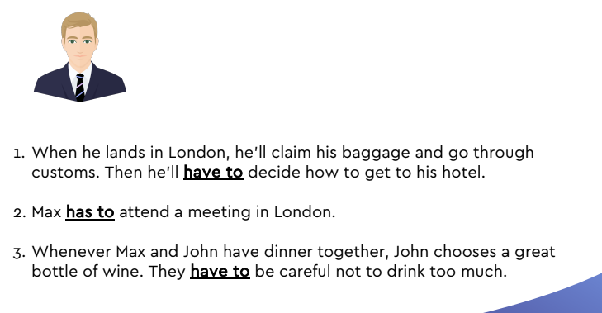

We have to buy airplane tickets.

We have to make hotel reservations.

We have to go to the airport two hours before our flight.

After we land, we have to get our baggage and go through customs.

We have to find out how much a taxi costs from the airport to ourhotel.

We have to check into the hotel.

We have to go to some business meetings.

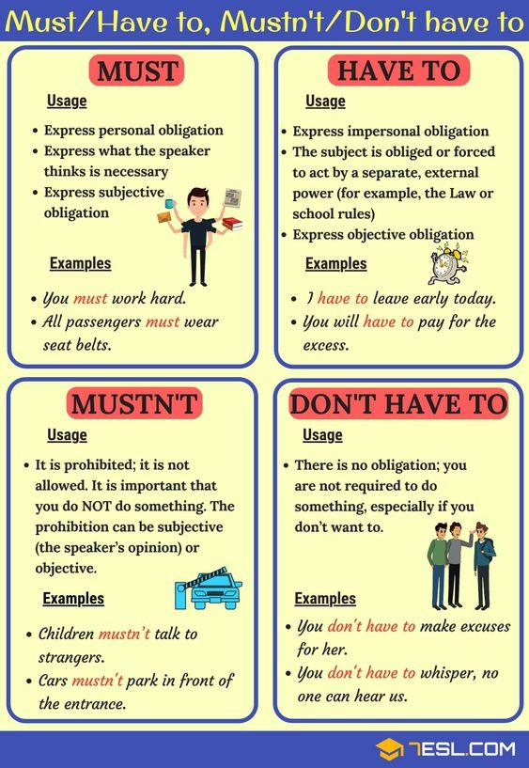

<https://test-english.com/grammar-points/a2/have-to-dont-have-to-must-mustnt/>

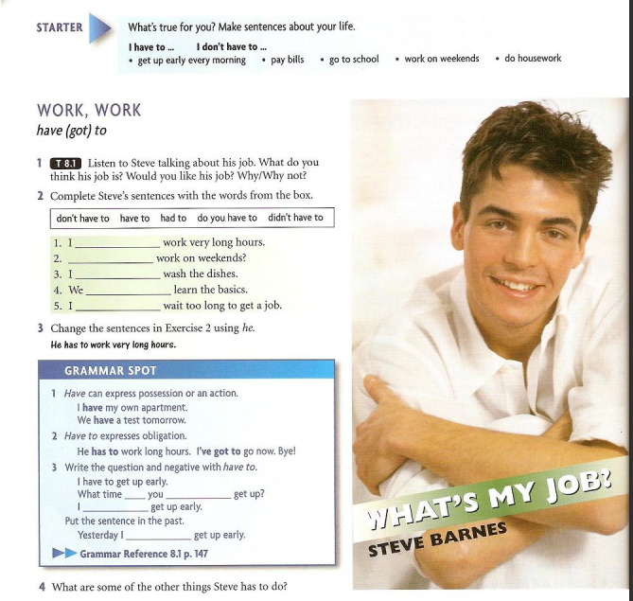

1. I have to work very long hours.

2- Do you have to work on weekends?

3-

<https://test-english.com/grammar-points/a2/have-to-dont-have-to-must-mustnt/>

4- Yes I do/ NO, I don´t

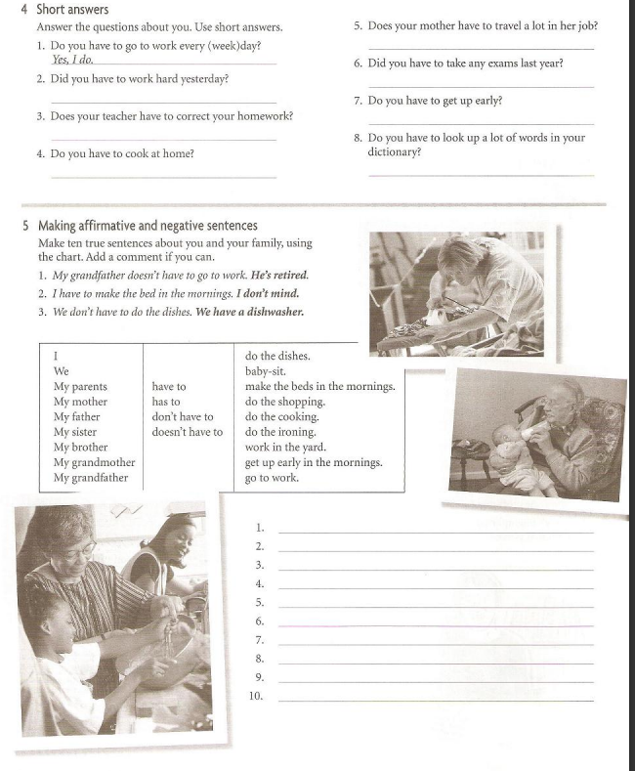

I have to get up early in the morning. I ´m employed.

We don’t have to do the ironing. WE have a service of cleaning.

My parents doesn’t have to go to work. They are retired.

My mother doesn´t have to get up early in the mornings. She´s retired.

My father doesn´t have to make the beds in the mornings. My mum does it.

My sister doesn´t have to baby sit. Her children are

My brother has to do the shopping to buy present for his wife.

My grandmother doesn´t have to do the dishes. She is dead.

My grandfather has to work in the yard. He lives in the country.

2- Yes, I DO /no, I DON´T.

3- YES, I DID / no, I DIDN´T

4- Yes I do/ NO, I don´t

5-yes, she does/ no, she doesn´t

6-yes, I did / no, I didn´t.

7- yes I do / no, I don´t

8- yes I do / no, I don´t.

**Certainty and Probability**

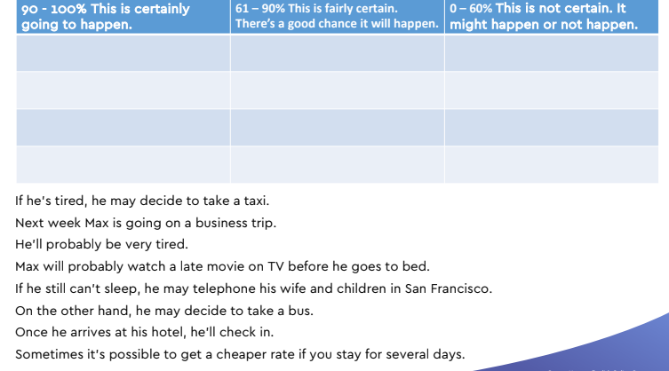

2. On the left, at the top, you see, “This is certainly going to happen.” In the middle are things that probably will happen. There is a good chance that they will happen. The right column is for sentences describing things we don’t know about for sure. They might happen or they might not happen.

4. Look at the sentences from Max’s trip to London. They describe parts of his business trip. These sentences describe things that might happen or might not happen. You have to put the sentences in the right column. Let’s do one together for each column.

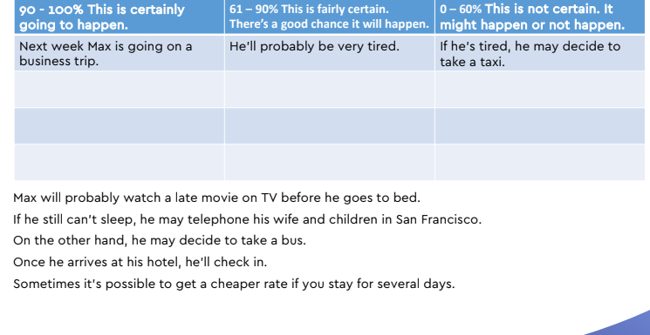

**Giving advice Choices and Ways**

Kim has just arrived at Heathrow Airport near London. He came from Hong Kong. Now he wants to get to his hotel in London.

3. **Look at the conversation**.

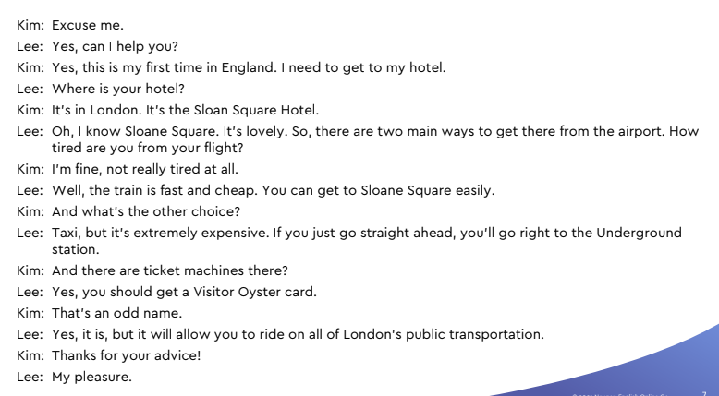

7. Kim and Lee discuss different choices or ways to get from the airport to the hotel. You can use the word “choice” or “way” to list these. Find a partner. Tell your partner two ways that you can get from your home to your job or school.

8. Look at a pair. Say: Tell me two ways that your partner can get to work or school. Continue asking pairs until everyone has answered.

